

**Introduction**

I created this form being compliant to GDPR sensitive data with a loving purpose. I chose this topic because my goal as a future Pastor is to bring the more people to Christ possible. I used this topic to analyse trends and patterns to reach that goal.

In this analysis, we examine various aspects of a person to understand factors influencing “Belief_Probability,” the likelihood that that individual believes Jesus wants to have a personal relationship with them. Through measures of central tendency, dispersion, shape, and normality testing, we will look for patterns and insights into the features (e.g., age, nationality, gender, prayer habits, family beliefs, etc.). This exploration involves visualizations and data analysis to understand belief trends and their roots clearly.

The data acquired thanks to this Google form has great importance in this study because it helps me, the data analytics guy, have an understanding of the person's characteristics to study.

**Measures of Dispersion**

Dispersion measures allow us to observe how the values of our dataset are spreaded out. The “Belief_Probability” shows a notable spread from the mean, indicating a wide range of belief probabilities among individuals, potentially diverse factors will influence one’s faith that we can study. In contrast, for example, “First_Heard_of_Jesus” is less dispersed and closer to the mean, showing that age and initial exposure to Jesus are within a more consistent range.

**Shape of Distribution**

**Skewness:** Seeing the skewness of “Belief_Probability” is (−0.56). This low and negative skewness reveals that higher belief probabilities are slightly more common in the dataset, a left skew. This means that a great amount of respondents are leaning towards a stronger belief in Jesus’s desire for a relationship with them. For “First_Heard_of_Jesus,” the skewness of (2.61) suggests a skew, in this case, toward lower values, younger ages, stating that many individuals first hear about Jesus at a very early age.

**Kurtosis**: The kurtosis measure for “First_Heard_of_Jesus” shows a peaked distribution, indicating potential outliers and a sharp focus around certain ages when people are firstly introduced to Jesus. Meanwhile, “Belief_Probability” has a flatter kurtosis, meaning the belief levels are more spread out without a distinct peak, this shows a broad expected spectrum of belief levels.

**Normality Test Results**

A normality test done on all numeric values based on their mean returned a p-value of 0.083, pointing out that our sample follows a normal distribution. This normally distributed dataset allows for really reliable analyses and statistical conclusions. Thanks to this, now we can proceed to deeper analyses of some specific features, as mentioned, we will focus our study on “Belief_Probability” and the factors influencing it.

**Belief_Probability Study**

“Belief_Probability” is key to our study as it reflects individuals’ conviction in Jesus’s desire to have a relationship with them, having in consideration distinct variables. We will identify factors associated with higher belief probability and understand how age, early exposure, family influence, prayer routines, or many other features may have an impact.

**Insights from Visualizations**

We will talk about the most important ones we found in this study:

1. **Belief Probability and Age of First Exposure to Jesus:** Visualizing belief probability against the age individuals first heard of Jesus reveals a strong pattern. Let’s see it:

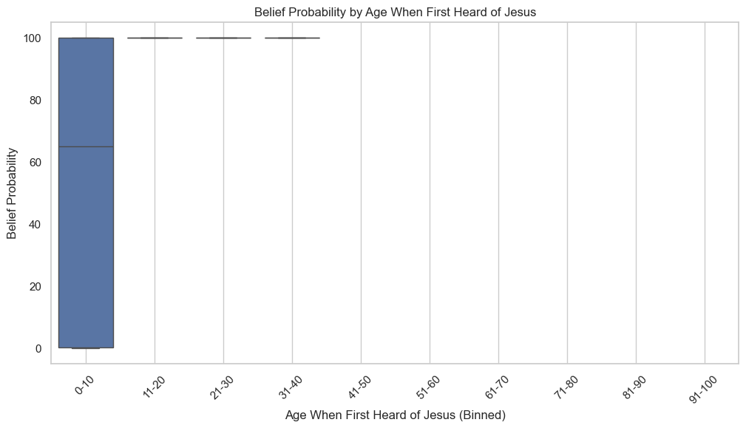

A higher Belief probability is clearly higher among those respondents introduced to Jesus before the age of 10. More than 60% of people who encountered Jesus’s teachings early in life have high belief probabilities in their adult life. This trend is one of the keys of our findings, it is crucial, it shows how important is the early exposure to religious teachings is shaping lifelong belief in a person.

1. 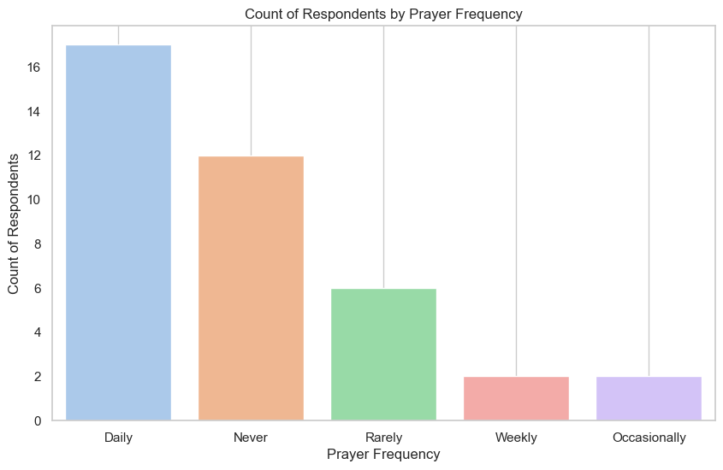**Prayer Frequency and Belief Probability:** Another important finding is the relationship between prayer frequency and belief probability. People who pray daily show higher belief probabilities, indicating that engagement with prayer reinforces belief. Interestingly enough, individuals who pray “occasionally” or even “never” still maintain some sort of high belief probability.

This pattern led me to further investigation. We found a significant number of respondents that selected the “Never” option. Meaning that it's high because many people answered that one. Still, this anomaly bring the question of why belief remains strong even among those people having a low prayer habit, stating that the belief in Jesus’s relational desire may be influenced by factors beyond our religious routines.

1. **Male vs Female:** Males, on average, reported higher belief probabilities than females. These results suggest that gender plays a role in belief probability, a person born male has a slightly stronger conviction in Jesus’s relationship with them.
2. **Role of Parents in Shaping Belief Probability:** Parental beliefs are strongly correlated with individual belief probability. The distribution of belief probability among parents mirrors almost exactly the Belief Probability distribution of the entire dataset. Let’s see it:

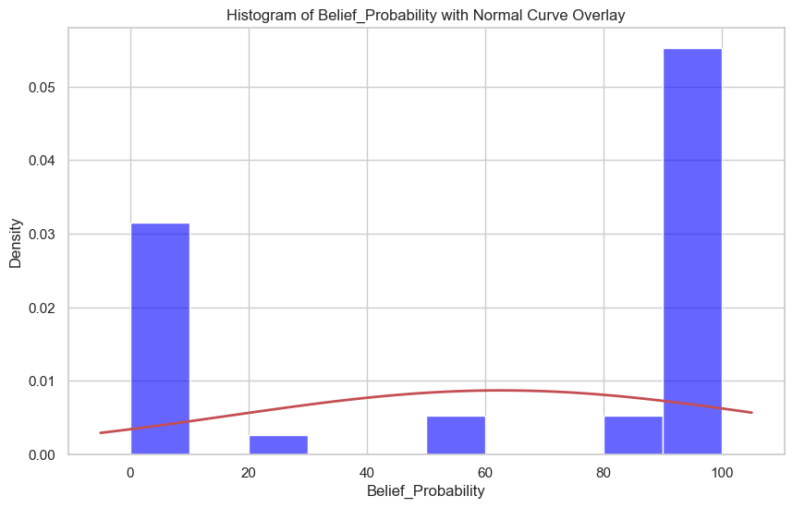**Histogram with Overlay Curve: Belief Probability**

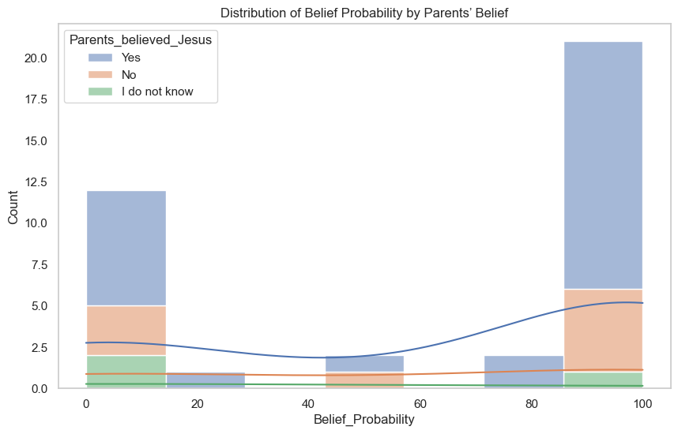**Belief Probability by Parents’ Belief**

**Conclusion**

- Most respondents were Females but Males are the ones who has a higher Belief_Probability. Making being born male a key factor of a person having a high Belief_Probability.

- Belief Probability vs. Current Age doesn't have any correlation at all but an early stage, from 0 until 10 years old, the study of the Scriptures guarantees a higher Belief_Probability for that person in their adult life.

- Now, talking about the parents, the parents have a huge impact on their kid's Belief_Probability. The Parents Belief distribution is almost identical to the whole dataset Belief_Probability distribution and we see the same here with the Irish people.

- Prayer Frequency: Something that stands out in this dataset. Males pray more frequently than females and pray frequency shifts drastically a person's Belief_Probability.

- Interestingly enough the majority of people believe in God, whether they have a high Belief_Probability, a prayer plan, a different Nationality, or any understanding of Jesus Christ. By knowing this we can potentially find an opportunity to make that person follow a prayer routine in their life boosting their Belief_Probability.

**In summary**, this study highlights the importance of an early stage of faith exposure, family influence, and prayer frequency in shaping belief probability of a person.

**Recommendation**

We need more committed parents in the development of their kids' relationship with Jesus if we want to see an increase in the Belief_Probability and creating ways in which people engage in prayer will secure growth in the Belief_Probability of the individual.